Bologna Method

1. Definitions
Binary rule –the rule, which has 2 agents in its left part and performs the binding on these agents.
For example: A(x, y), B(u) → A(x!1, y), B(u!1)

Reaction –the transformation of the solution, caused by application of any rule.

Unary reaction –the reaction, which modifies only one connected component in the solution. In other words, there are 2 injections in the left part of R, both pointing to the same connected component.

Following picture illustrates unary reaction induced by application of A(x),B(u) -> A(x!1),B(x!u)
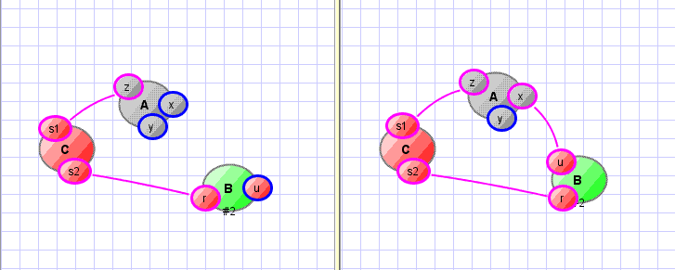
Binary reaction –the reaction, caused by the binary rule R, which modifies two or more connected components in the solution.

Following picture illustrates binary reaction induced by application of A(x),B(u) -> A(x!1),B(x!u)
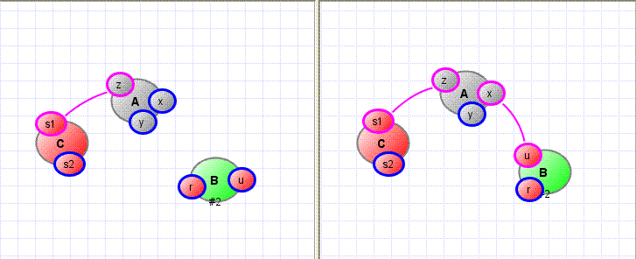
R.apply(φ, ψ) – the application of the binary rule R induced by injection φ from the first agent and ψ from the second agent.
2. Goal

Goal 1: binary reaction should have activity calculated with rate k2 and unary reaction should have activity computed with rate k1 (that doesn't depend on the volume).
Goal 2: prevent polymers

3. Algorithm

The line in kappa for rule R is as follows
A(x), B(x) -> A(x!1), B(x!1) @ k1(k2), where
k1 is the “rate” at which unary cases should be applied
k2 is the “rate” at which binary cases should be applied

The Bologna method describes how we should apply this rule in common case.
Calculating the activity of R:
Let Φ be a set of injections from the 1st component in the left part of the rule to the solution,
and Ψ - a set of injections from the 2nd component in the left part of the rule to the solution.
Define k₂' = max (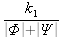, k₂)
So, instead of we compute the activity on each iteration as
Then what happens if R is chosen to be applied?
- Choose 2 injections to the solution from left part of R: φ from Φ and ψ from Ψ.
The possible cases of φ and ψ are:
a) (φ, ψ) induces a unary reaction:
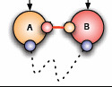
b) (φ, ψ) induces a binary polymerizing reaction:

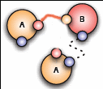
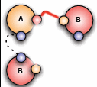
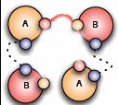
b.1 b.2 b.3
c) (φ, ψ) induces a “simple” (not polymerizing) binary reaction:
- In case c), perform R.apply(φ, ψ) with probability P_{inter} = and stop.
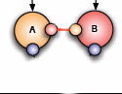
- In case b), swap connections in order to obtain the unary reaction:
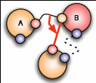
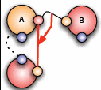
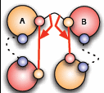
Swap at this point obviously means changing one (φ or ψ) injection to the other injection 'T' as represented on the images. If there is more than one injection to choose from, then the algorithm takes 'T' randomly.
- What we want now is applying some reaction.
Define P_{intra} = 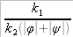.
Case b)
- In b.1 and b.2 we should swap initial (black) connection with the red one and perform obtained reaction (creation of the red connection) with probability P_{intra}.
- In b.3 we should swap black connection with the “left” one first and try to perform obtained reaction R1 (creation of the “left” red connection) with probability P_{intra}.
Then, if no luck and nothing was applied, we should try to perform reaction R2 (creation of the “right” red connection) either with probability P_{intra}.
Case a)
This is an unary reaction, which the algorithm should perform with probability P_{intra}.
- If nothing was applied, then the algorithm says “reject!”, increases time and goes on with further iterations.

4. Algorithm Flowchart
